Chapter 9, Problem 17.

Two voltages v₁ and v₂ appear in series so that their sum is v = v₁ + v₂. If 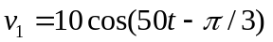 V and v₂ = 12cos(50t + 30˚) V. Find v.

